PERSONALIZED E-LEARNING COURSE RECOMMENDATION SYSTEM
Block Diagrams (all)
Department of Computer Science and Engineering, [COLLEGE NAME]
Batch C7 (CSE-C) · Academic year [ACADEMIC YEAR]
Table 1: Project team
S.No. | Student name | Roll number
1 | PITTALA AKHILA | 23K91A05J3
2 | MUNDALA SANDHYA | 23K91A05G5
3 | MULA THANUJ REDDY | 23K91A05G4
4 | MAJJIGAPU JAGADESHWAR REDDY | 23K91A05E1

Project guide: K GAYATHRI
Chapter and section numbers quoted in the text (for example Section 6.6 or Chapter 8) refer to the full project report, 17.Final Document. Figures and tables in this document are numbered from 1.

1. INDEX OF DIAGRAMS
Every diagram is generated from the real design by scripts/make_diagrams.py (matplotlib, 150 dpi) and mirrors the code in app/main.py, app/api_routes.py, app/recommender.py, app/models.py and scripts/train_pipeline.py.
Table 2: Diagrams in this document
No. | Diagram | Image file
1 | System architecture | docs/diagrams/01_system_architecture.png
2 | High-level workflow | docs/diagrams/02_high_level_workflow.png
3 | Data flow diagram, level 0 | docs/diagrams/03_dfd_level0.png
4 | Data flow diagram, level 1 | docs/diagrams/04_dfd_level1.png
5 | Data flow diagram, level 2 | docs/diagrams/05_dfd_level2.png
6 | UML class diagram | docs/diagrams/06_uml_class_diagram.png
7 | Sequence diagram | docs/diagrams/07_sequence_diagram.png
8 | Use-case diagram | docs/diagrams/08_use_case_diagram.png
9 | Entity-relationship diagram | docs/diagrams/09_er_diagram.png
10 | Flowchart of the core algorithm | docs/diagrams/10_core_algorithm_flowchart.png

2. DIAGRAMS

System architecture
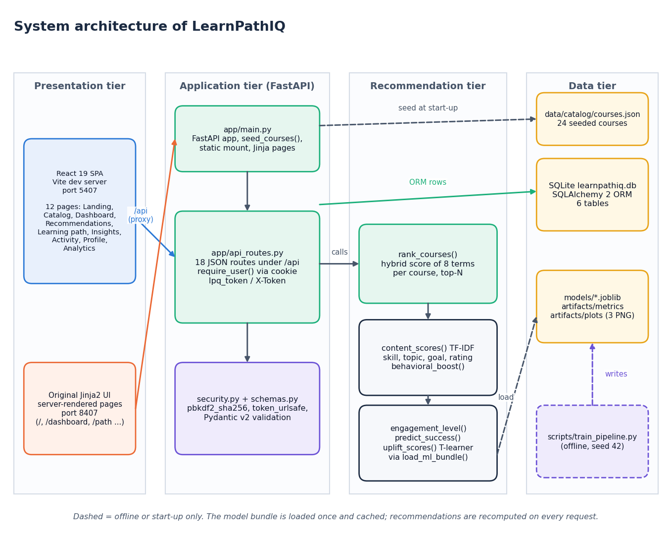
Figure 1: System architecture of LearnPathIQ
The system has four tiers. In the presentation tier the React 19 single-page application (Vite development server, port 5407) and the original server-rendered Jinja2 interface (port 8407) are the two ways a learner reaches the system; the React server proxies /api and /static to the backend so the session cookie stays same-origin. The application tier is the FastAPI service: app/main.py creates the application, seeds the course table, mounts the static folder and serves the Jinja pages, while app/api_routes.py holds the 18 JSON routes under /api and resolves the learner from the lpq_token cookie or the X-Token header; security.py and schemas.py supply password hashing, token generation and request validation. The recommendation tier is app/recommender.py: rank_courses() combines the TF-IDF, skill, topic, goal, rating and behaviour terms with the engagement score, the predicted success probability and the per-action uplift, and the model bundle is read once through load_ml_bundle(). The data tier holds the SQLite file learnpathiq.db (six tables), the 24-course catalogue in data/catalog/courses.json that seeds the course table at start-up, and the trained artefacts (models/*.joblib, artifacts/metrics, artifacts/plots), which the offline script scripts/train_pipeline.py writes. Dashed arrows are start-up or offline only.

High-level workflow
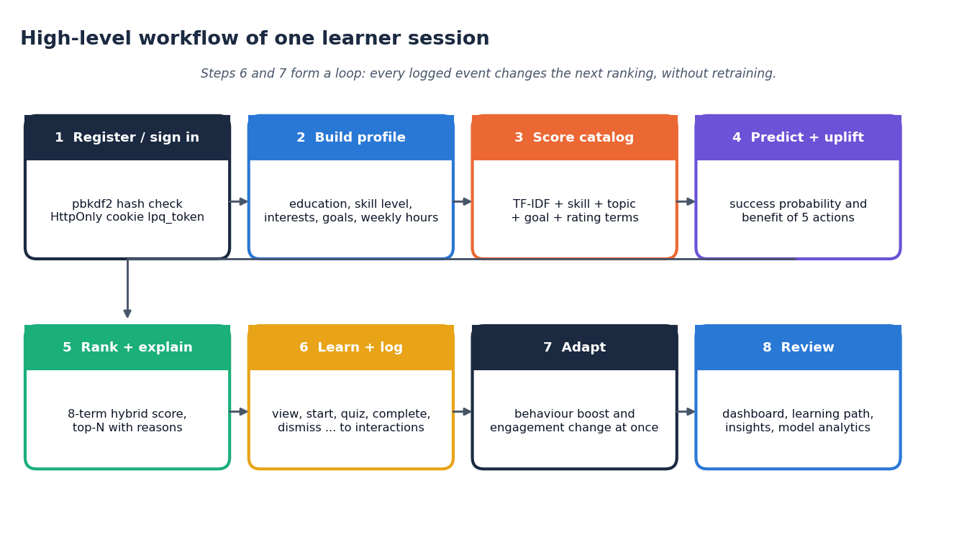
Figure 2: High-level workflow of one learner session
A session has eight steps. The learner registers or signs in (the password is checked against its PBKDF2 hash and an HttpOnly cookie is set), builds a profile (education, skill level, interests, preferred topics, goals, weekly hours), and the system scores the catalogue against it. The learner state is then fed to the success model and the action-benefit models, the eight terms are combined into a ranked list with a short explanation per course, and the learner acts on it (view, start, quiz, complete, dismiss and so on), each action being written to the interactions table. Because the behaviour and engagement terms are recomputed from that table on every request, the next ranking changes at once without retraining; the dashboard, learning path, insights and model analytics screens present the result. Steps 6 and 7 form the feedback loop.

Data flow diagram, level 0
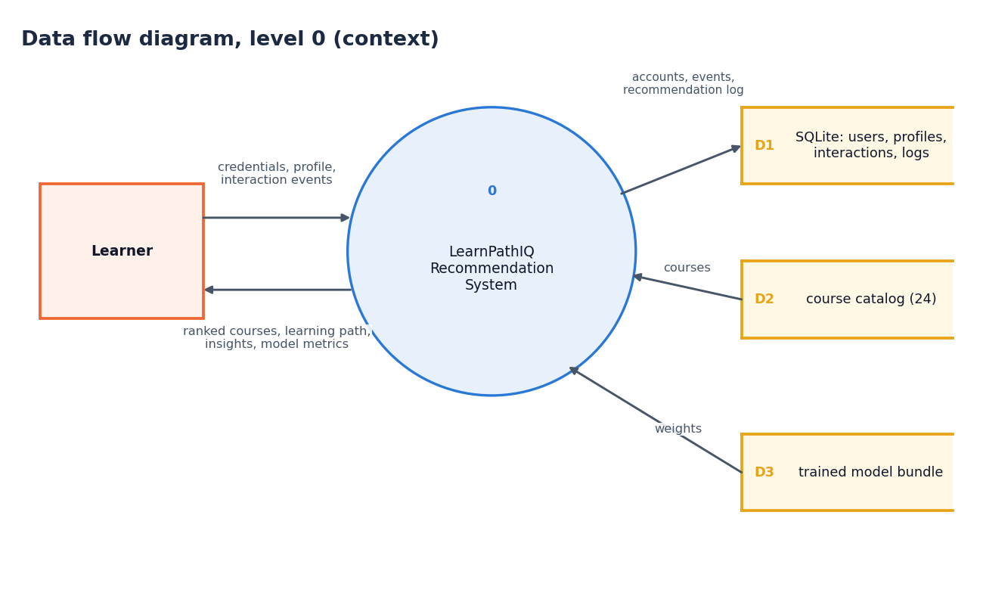
Figure 3: Data flow diagram, level 0 (context diagram)
The context diagram shows LearnPathIQ as a single process with one external entity, the learner. The learner sends credentials, profile data and interaction events; the system returns ranked courses, the learning path, insights and model metrics. Internally the process reads and writes the SQLite store (D1: users, profiles, interactions and the recommendation log), reads the course catalogue (D2) and reads the trained model bundle (D3).

Data flow diagram, level 1
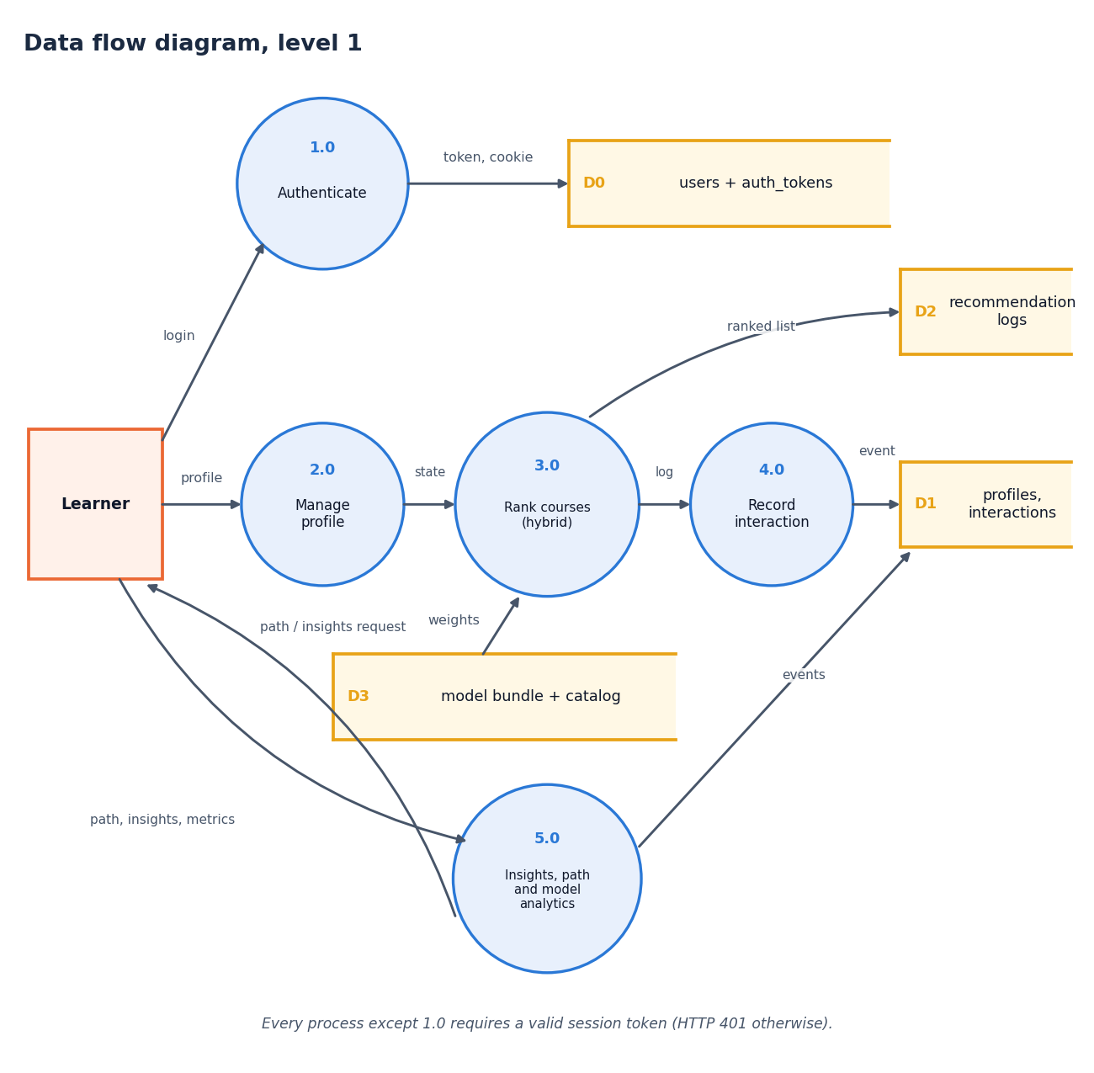
Figure 4: Data flow diagram, level 1
Level 1 has five processes. Authenticate (1.0) checks credentials against the users and tokens store (D0) and issues the token and cookie. Manage profile (2.0) accepts the profile and passes the learner state on to Rank courses (3.0), which reads the model bundle and catalogue (D3) and writes the ranked list to the recommendation log (D2). Record interaction (4.0) writes each event to the profiles and interactions store (D1), and the log from 3.0 feeds it. Insights, path and model analytics (5.0) reads the stored events and returns the learning path, the insights and the model metrics. Every process except 1.0 requires a valid session token and answers HTTP 401 otherwise (the public catalogue and model-analytics routes are the exceptions described in Section 5.7).

Data flow diagram, level 2
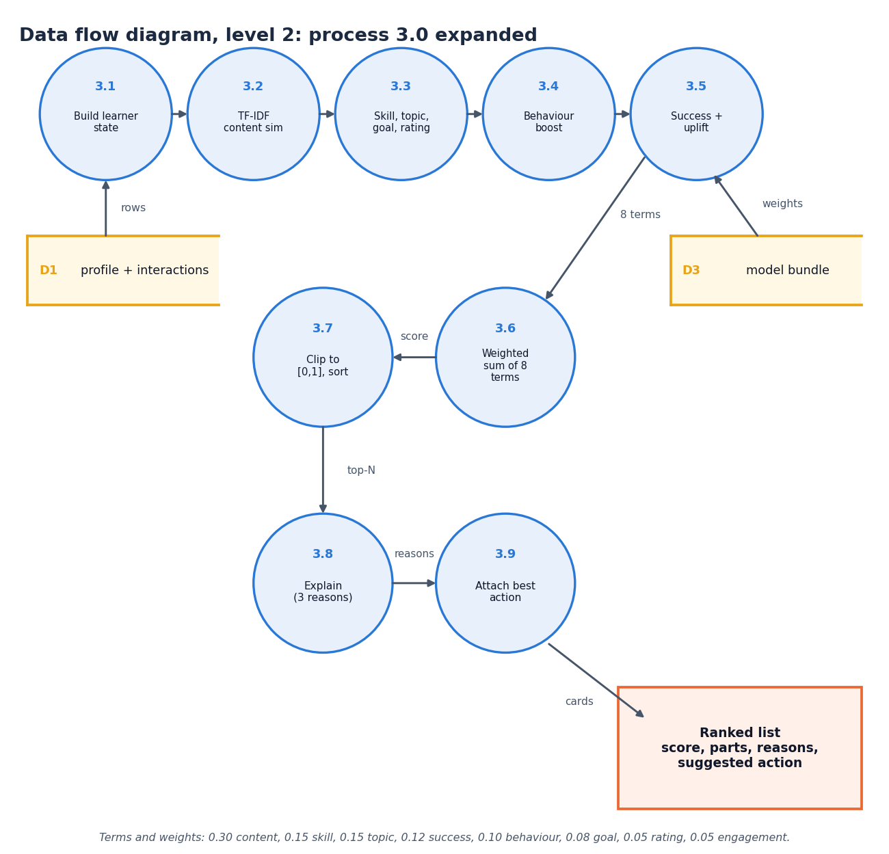
Figure 5: Data flow diagram, level 2: process 3.0 expanded
Level 2 expands the ranking process into nine steps. The learner state is built from the profile and the stored interactions (3.1); the TF-IDF content similarity of the profile against each course text is computed (3.2); the skill-compatibility, topic-interest, goal and rating terms follow (3.3) together with the behavioural boost from earlier events (3.4); the success probability and the per-action uplift come from the model bundle (3.5). The eight terms are combined by a weighted sum (3.6), clipped to [0, 1] and sorted (3.7), up to three reasons are attached to each course (3.8) and the best action (the action with the largest estimated benefit) is attached to every card (3.9). The weights are 0.30, 0.15, 0.15, 0.12, 0.10, 0.08, 0.05 and 0.05.

UML class diagram
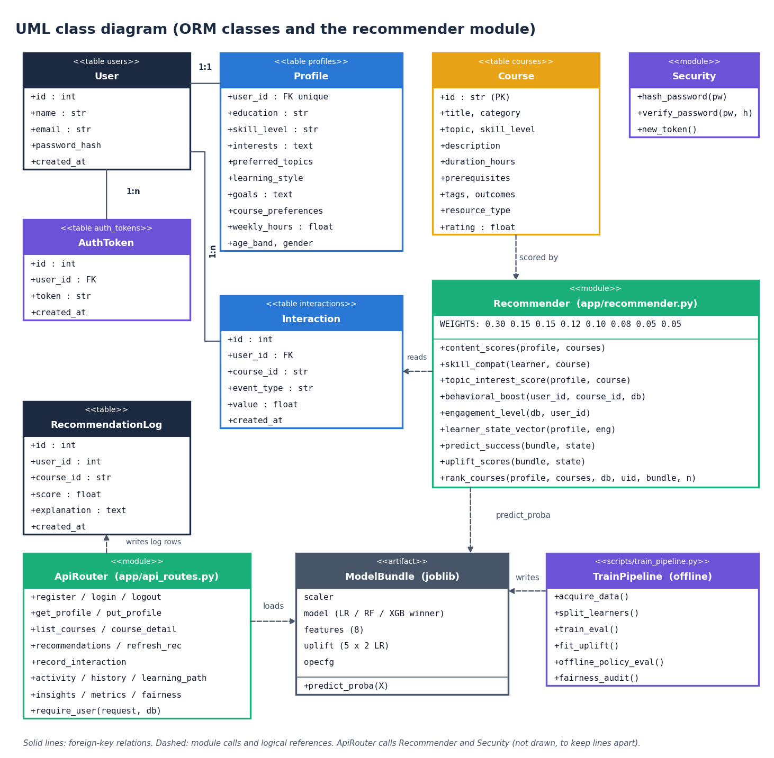
Figure 6: UML class diagram (ORM classes and the recommender module)
The six database tables are mapped by SQLAlchemy classes: User has one Profile and many AuthToken and Interaction rows; Course and RecommendationLog are standalone (the log stores the user and course ids as plain columns). The Recommender module (app/recommender.py) is drawn as a class stereotyped as a module, listing its public functions and the weight vector; it reads Interaction rows, scores Course rows and calls the ModelBundle (the joblib artefact: scaler, selected model, feature list, one-vs-rest uplift models and the policy-evaluation configuration) through predict_proba. ApiRouter (app/api_routes.py) loads the bundle, writes the log rows and uses Security for hashing and tokens; TrainPipeline (scripts/train_pipeline.py) runs offline and writes the bundle. The code base is function-oriented, so modules stand in for classes except in the ORM layer.

Sequence diagram
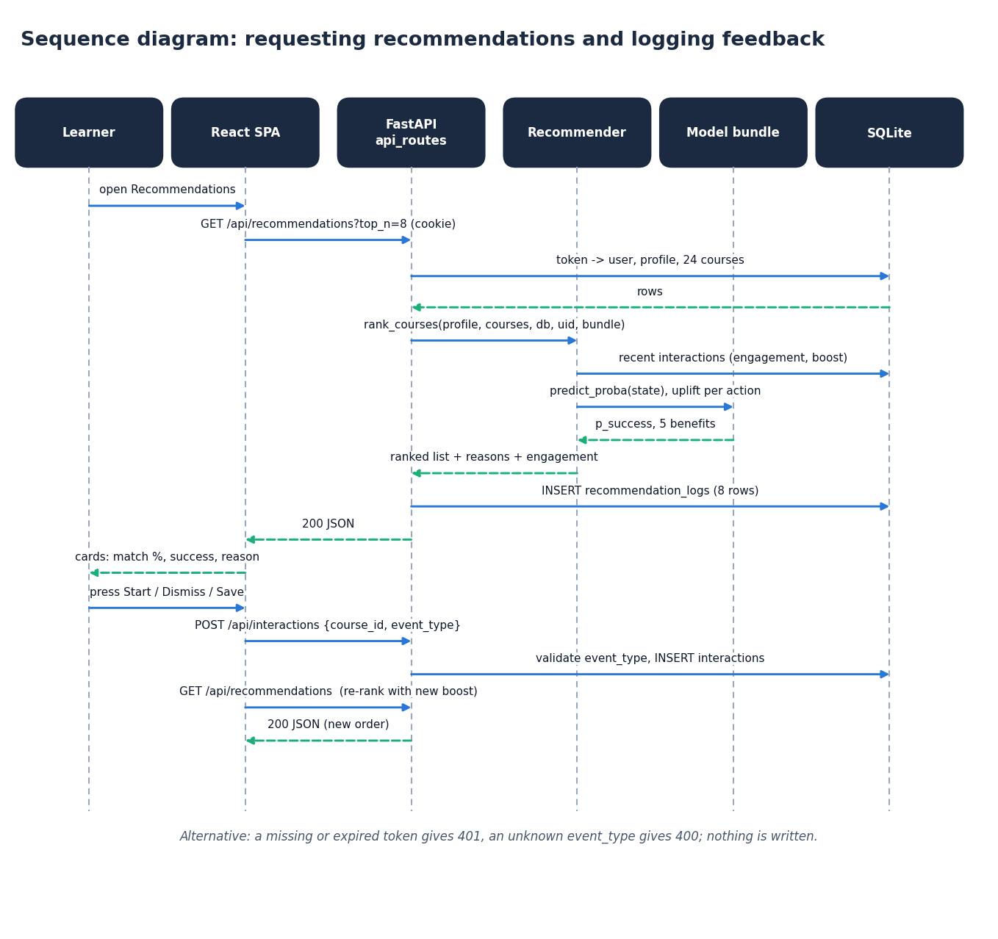
Figure 7: Sequence diagram: requesting recommendations and logging feedback
The sequence follows one pass of the feedback loop. Opening the Recommendations page makes the React app call GET /api/recommendations?top_n=8 with the session cookie. The API resolves the token to a user and loads the profile and the 24 courses from SQLite, then calls rank_courses(). The recommender reads the learner's recent interactions (engagement and boost), asks the model bundle for the success probability and the five action benefits, and returns the ranked list with reasons. The API stores one recommendation_logs row per card and returns the JSON; the page shows the cards. When the learner presses Start, Dismiss or Save, the page posts {course_id, event_type} to /api/interactions; the API validates the event type and inserts the row, and the next GET /api/recommendations returns a list ranked with the new behaviour boost. A missing token gives 401 and an unknown event type gives 400, and nothing is written.

Use-case diagram
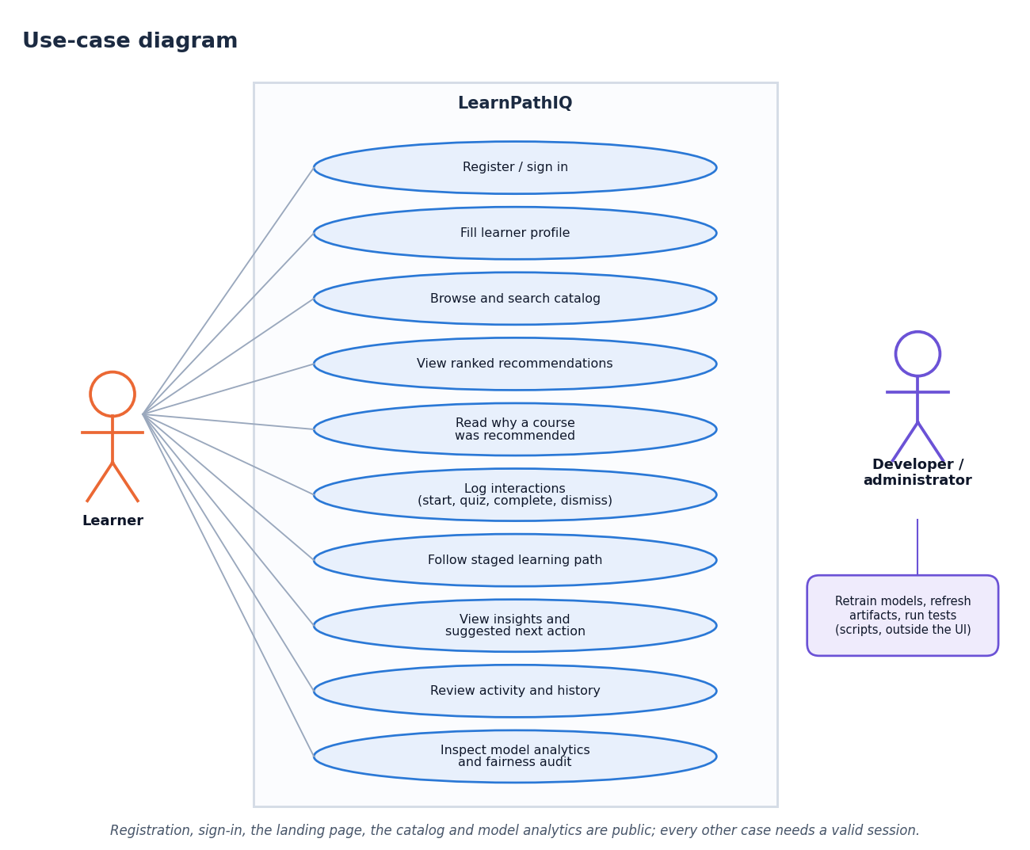
Figure 8: Use-case diagram
The learner can register or sign in, fill the profile, browse and search the catalogue, view ranked recommendations and the reasons for each, log interactions (start, quiz, complete, dismiss and so on), follow the staged learning path, read insights and the suggested next action, review the activity log and recommendation history, and inspect the model analytics and fairness audit. The catalogue, the course detail and the analytics routes are public in the code; the profile, recommendation, path, insight, activity and interaction routes require a session. The developer or administrator is a second actor who retrains the models, refreshes the artefacts and runs the tests with scripts outside the web interface.

Entity-relationship diagram
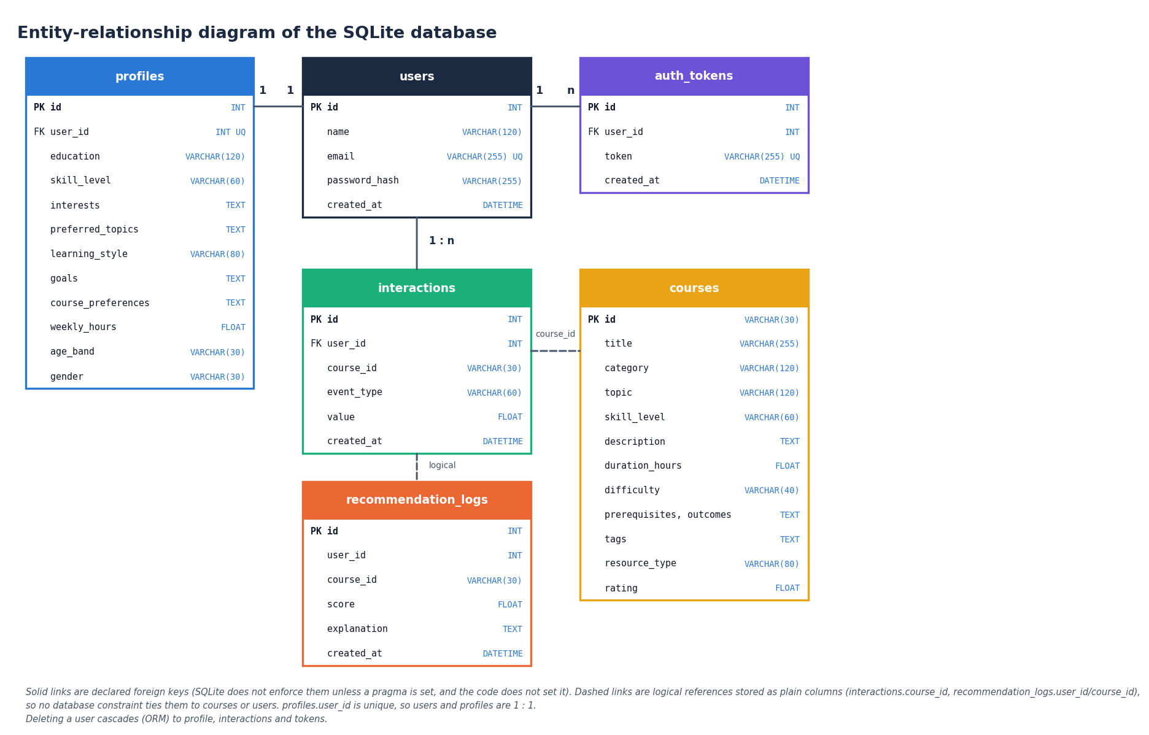
Figure 9: Entity-relationship diagram of the SQLite database
The database has six tables. users is the parent of profiles (one to one, because profiles.user_id is unique), auth_tokens (one to many) and interactions (one to many); these three links are declared foreign keys, and the ORM relationships cascade deletion from a user to its profile, interactions and tokens. courses is referenced by interactions.course_id and recommendation_logs.course_id, and recommendation_logs.user_id refers to a user, but these are plain columns without a declared foreign key, so no database constraint ties them to their parent. SQLite does not enforce declared foreign keys unless a pragma is switched on, and the code does not switch it on.

Flowchart of the core algorithm
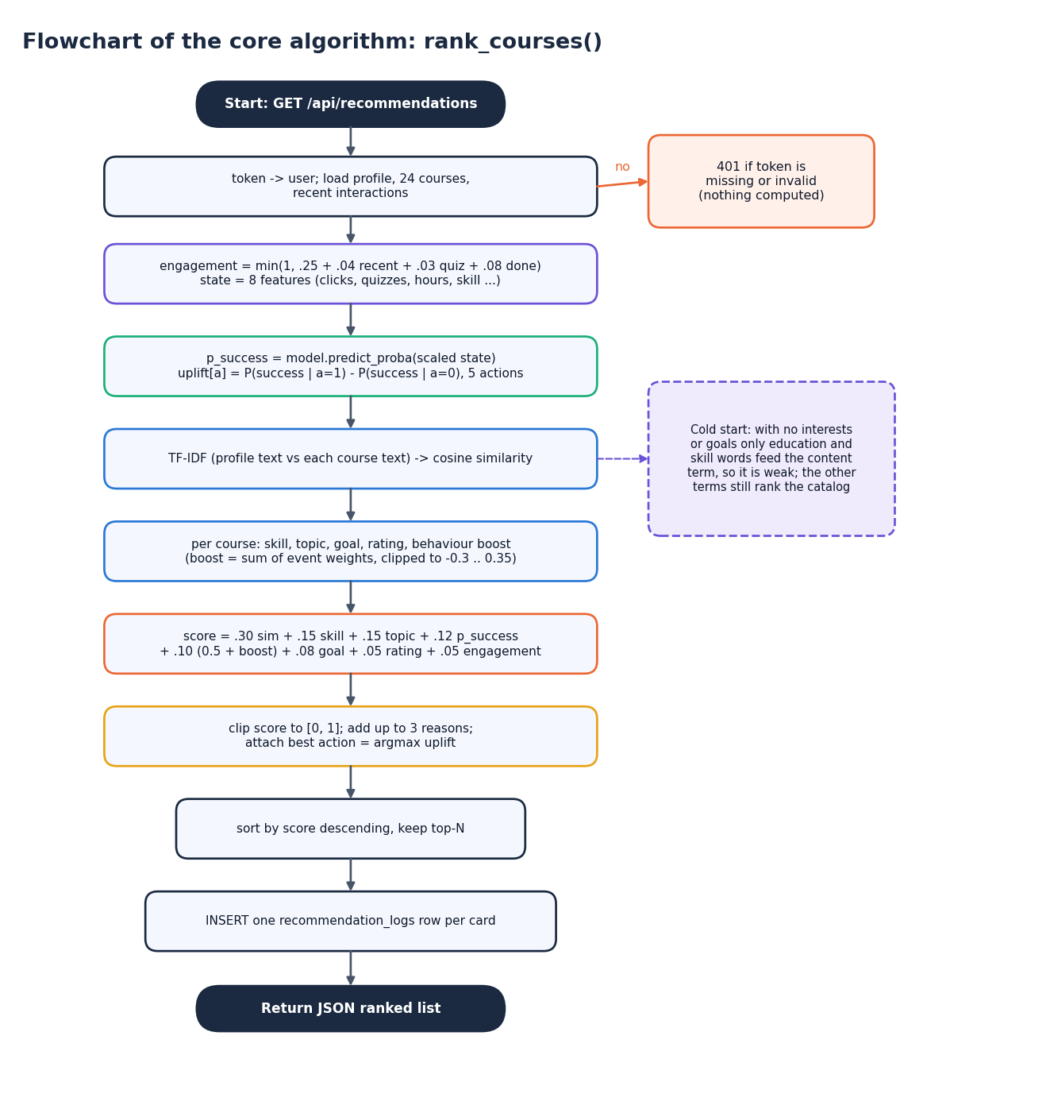
Figure 10: Flowchart of the core algorithm: rank_courses()
The flowchart gives the steps of GET /api/recommendations in order. A missing or invalid token ends the request with 401. Otherwise the profile, the 24 courses and the recent interactions are loaded; the engagement score and the eight-feature learner state are built; the success probability and the per-action uplift are computed; the TF-IDF cosine similarity is computed once for all courses; and for each course the skill, topic, goal, rating and behaviour terms are added to form the weighted score, which is clipped to [0, 1]. Up to three reasons and the best action are attached, the list is sorted and cut to the top N, and one recommendation_logs row is inserted per card before the JSON is returned. With no interests or goals the content term is weak (only the education and skill words feed it) but the other terms still rank the catalogue.

